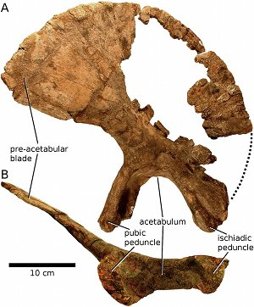
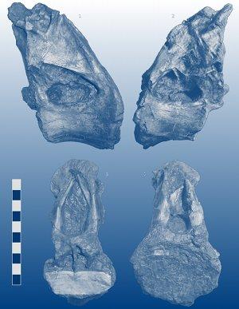

Title of some journal

Certificate of publication for the article called
Title of your paper, which is in a much smaller font than
the journal because journals are more important

Authored by
List of author names, also much smaller
than the journal title.

Published in
Volume 12, Issue 34, Pages 56-78

