DIRECTIONS FROM M5

M5 south to Angel Hotel, Cardiff

Head northeast on M5
At junction 15 exit onto M4
At junction 29, exit M4 towards Caerdydd
Merge onto A48(M)
Exit onto A48/Eastern Avenue N
At the roundabout take the 2nd exit onto A470/N Rd E
Take the ramp onto N Rd
Turn right onto A4161

M5 north to Angel Hotel, Cardiff

M62 south
At junction 10 exit onto M6 towards Birmingham/Chester/M56
Take exit for M5
Take exit for M4 towards London/Bristol (head towards Newport)
At junction 29 exit towards Caerdydd
Merge onto A48
Exit onto A48/Eastern Ave N
At roundabout take the 2nd exit onto A470/N Rd E
Turn right onto A4161

MAP OF LOCATION – Angel Hotel

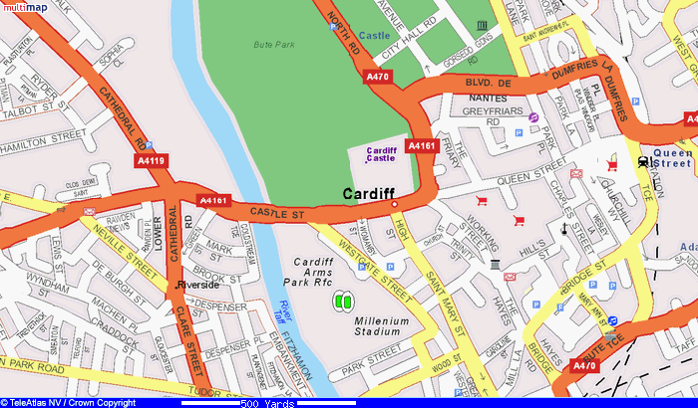
LOCATION
CARDIFF CASTLE

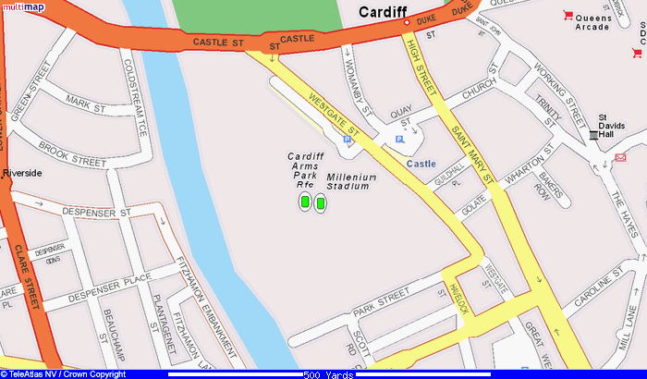
Millenium Stadium
Location
Cardiff Castle
Cardiff Market

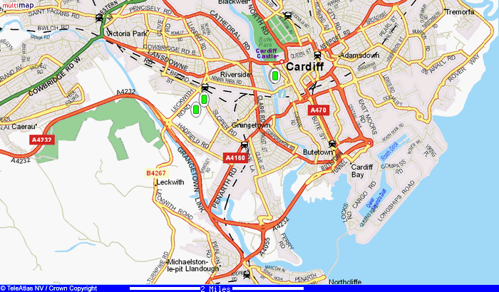
LOCATION

MAP OF CARDIFF

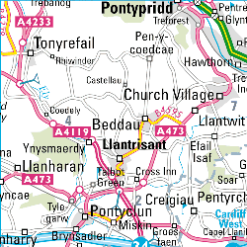 | 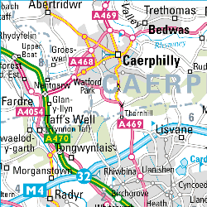 | 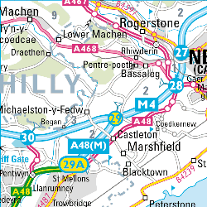
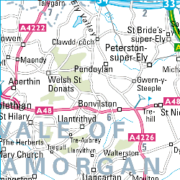 | 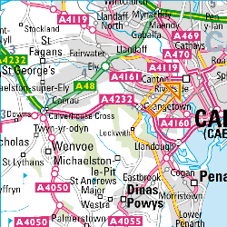  LOCATION | 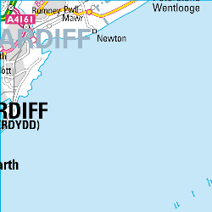
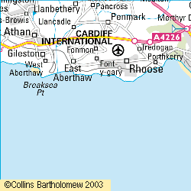 | 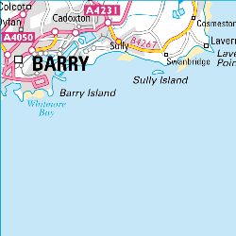 | 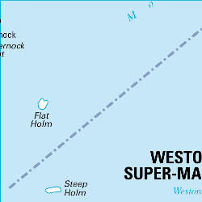

MAP OF CARDIFF BAY

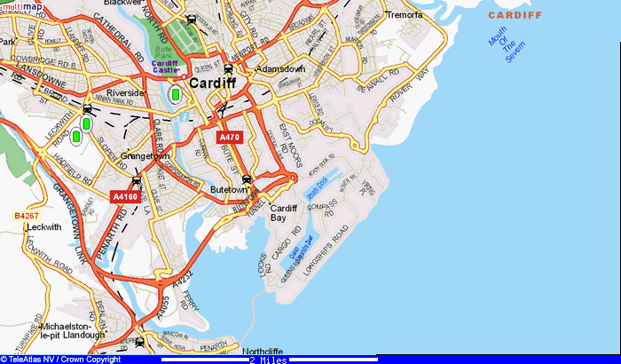

A MAP OF THE AREA

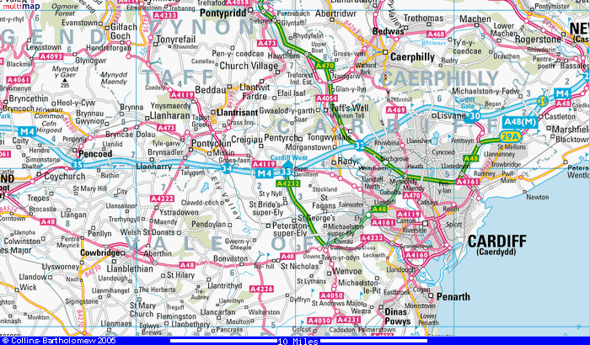

PARKING IN CARDIFF BAY

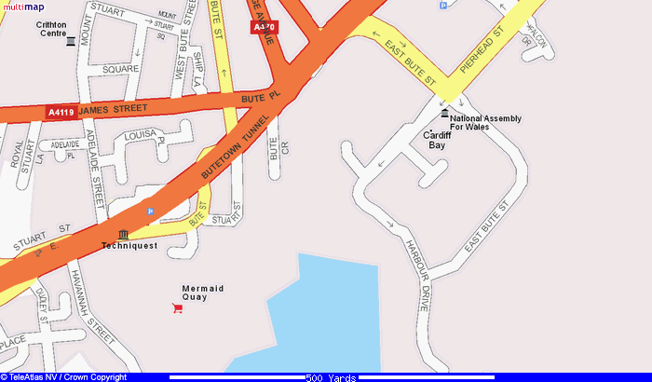
Brute Crescent
Stuart St
6’7 ht restriction
Havannah Street
Millenium Centre P
Harbour Drive
Millenium Centre

